EXPERIMENT 4
ROLL NO: 240701179 NAME: J.Harsan
Create a prototype with familiar and unfamiliar navigation elements. Evaluate ease of use with different user groups using proto.io

Screen 1:
Sign In page for the destination app

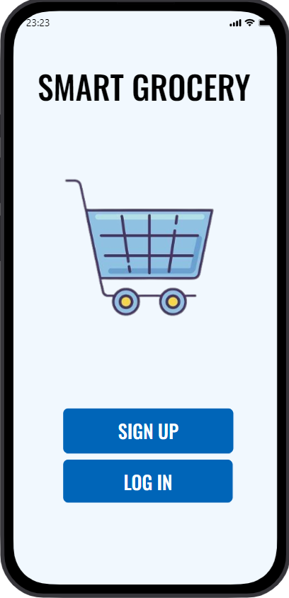
Login Page:
Familiar elements:
1.App Logo & Title – Top Center:
. Displays the app name (e.g., Smart Grocery) for brand identity.
. Helps users confirm they are in the correct application.

2.Username / Email Field – Below Title:
. standard input field where users enter their registered email or username.
.Often includes a user/email icon inside the text box.

3.Password Field – Below Username:
. Secure input field where characters are hidden (••••••).
. May include a “show/hide password” (👁) icon.

4.Login Button – Centered Below Fields:
. Primary action button to access the account. . Clearly highlighted to attract user attention.
Screen 2:
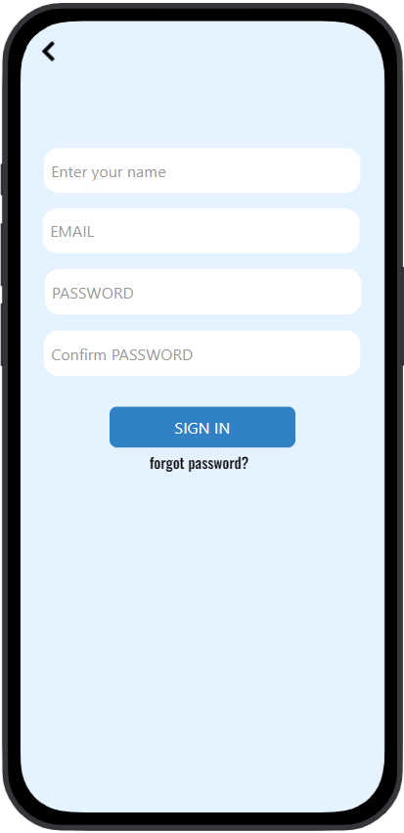
Familiar elements.

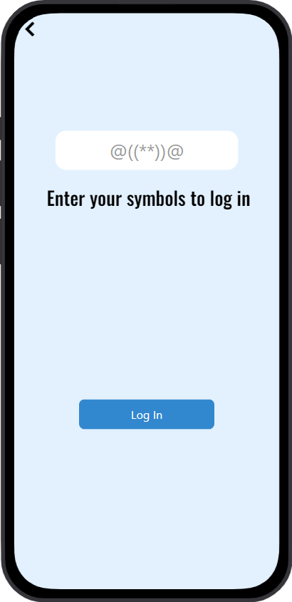
unFamiliar elements:
1.symbols Inside Input Fields:
.Using random symbols ( etc.) instead of standard icons (email , password ) is unusual.
. Users may not understand what each field represents (username or password).

2.symbols in Field:
. These icons do not clearly indicate a login function.
. They may confuse users about what information to enter.

3.enter your symbols ??” Text:
. This message is unclear and grammatically confusing.
. Typically, it should say “Forgot Password?” .

4.Lack of Clear Field Labels:
. No visible “Email” or “Password” labels.
. Users rely only on emojis, which is not standard UI practice.

5.Dark Background with Low Contrast Text:
.Some text is difficult to read.
. Reduces accessibility and usability.
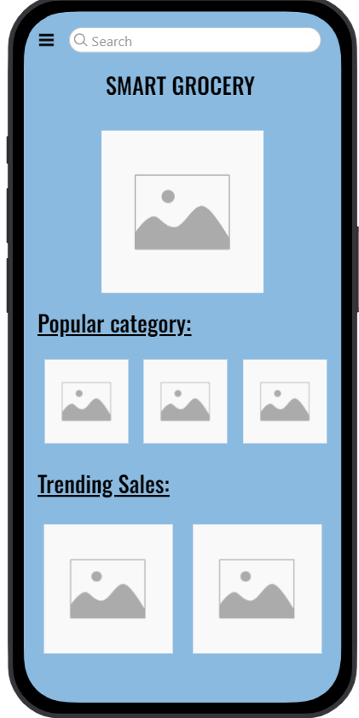
Screen3:
Familiar Icons / Elements:
1.Hamburger Menu (☰) – Top Left:
. Common icon used to open the navigation menu.
. Usually contains options like Home, Categories, Orders, and Settings.

2.Search Bar ( ) – Top:
. Standard search field with magnifying glass icon.
. Allows users to search for products quickly.

3.App Title – “Smart Grocery”:
.Displays the brand name clearly.
. Helps users confirm they are on the home screen.

4.Promotional Banner:
. Common e-commerce feature showing offers or discounts.
. Visually attractive section to highlight deals.

5.Category Icons:
. Grid layout commonly used in shopping apps.
Easy navigation to different product sections.

6.Trending Deals Section:
. Standard section highlighting popular or discounted items.
. Helps users discover featured products.

8.Add to Cart Button:
. Common e-commerce action button.
. Allows users to quickly add items to their shopping cart.
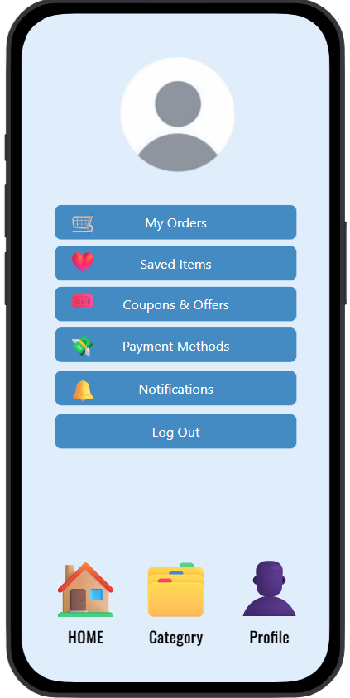

Screen4:
Familiar Icons / Elements:
1.Profile Picture – Top Center:
○ Circular avatar image representing the user.
○ Common design pattern in account/profile pages.

2.User Name & Email Display – Below Profile Image: ○ Shows logged-in user information.
○ Standard feature for personalization and identification.

3.My Orders ( Icon):
○ Common option in shopping apps to view order history.
○ Cart icon represents purchases.

4.Saved Items ( Icon):
○ Heart icon commonly represents favorites or wishlist.
○ Allows users to view saved products.

5.Coupons & Offers (🎟 / Tag Icon):
○ Standard section for discounts and promo codes.
○ Frequently used in e-commerce apps.

6.Payment Methods ( Icon):
○ Card icon represents stored payment options.
○ Used to manage debit/credit cards or other payment types.

7.Notifications ( Icon):
○ Bell icon universally represents alerts and updates.

8.Log Out (⏻ Power Icon):
○ Power symbol commonly used to indicate logout action.

9.Bottom Navigation Bar (Home, Categories, Account): ○ Home ( ) – Returns to main page.
○ Categories ( ) – Browse product sections.
○ Account ( ) – Access profile settings.
○ Standard bottom navigation pattern in mobile apps.

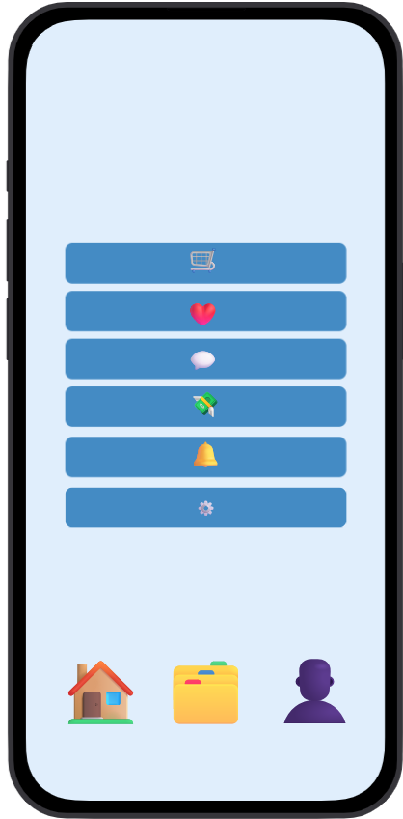

Unfamiliar Elements:

1.Search Bar with Clock Icon (⏱) – Top:
○ A clock icon inside a search bar is unusual.
○ Users typically expect a magnifying glass ( ) for search.
○ The meaning (recent search? timer?) is unclear.

2.Truck Icon ( ) Without Label:
○ Could represent delivery or orders, but no text is provided.
○ Users must guess its function.

3.Barcode Icon Without Text:
○ Might mean scan product or product code.
○ Without label, it is confusing.

4.Clipboard Icon Without Label:
○ Could represent orders, list, or reports.
○ No text makes its purpose unclear.

5.Triangle Icon (△) – Middle Section:
○ Not a common navigation symbol in shopping apps.
○ Meaning is ambiguous.

6.Light Bulb Icon ( ) Without Explanation ○ Could represent tips or suggestions.
○ Not clearly defined in this context.

7.Chat Bubble Icon ( ) Without Label: ○ Might indicate support or messages.
○ Users may not immediately understand.

8.Settings Gear Icon (⚙) – No Text:
○ Common icon, but still lacks a label for clarity.

9.Bottom Navigation Icons Without Text:
○ Home ( ), Categories ( ), Profile ( ) appear without labels.
○ Icons alone may confuse some users.

10.Low Visibility / Dark Contrast:
○ Icons and lines are faint and hard to see. ○ Reduces usability and accessibility.

